Arrays Past paper Questions



2018

2019

2022 – session 1

Session 2

2023 – session 1

Session 2

Extra model question



2018

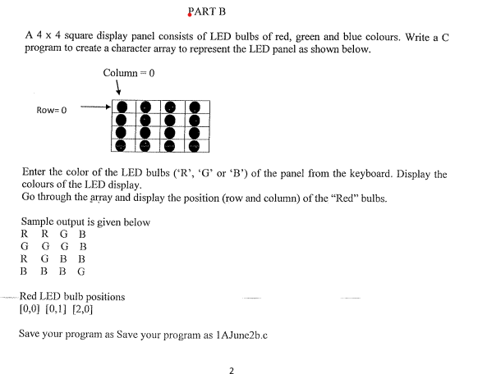

2019

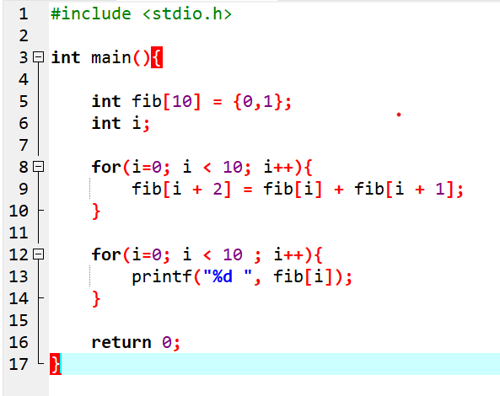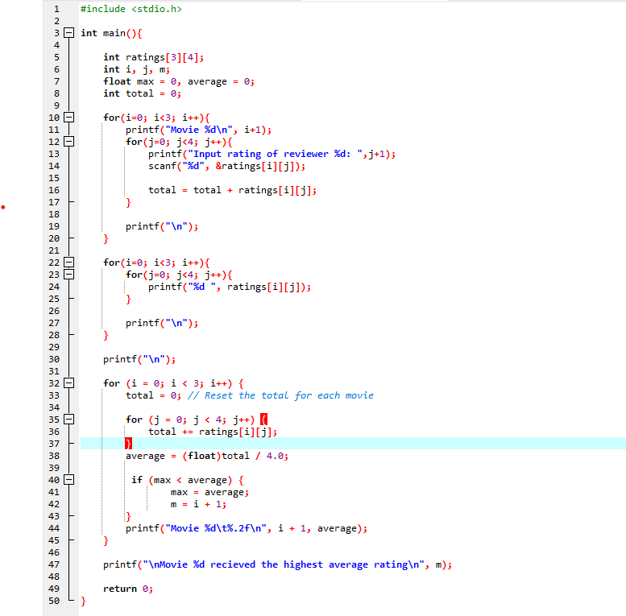

Part A

Part B

2022- session1

Part a

Part b

2022- session2

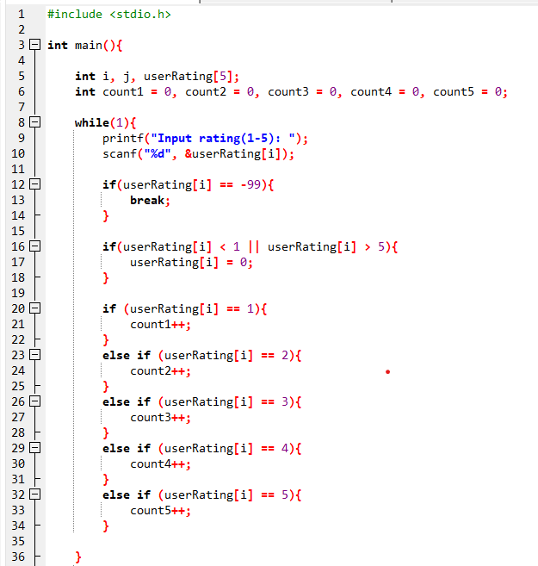

Part a

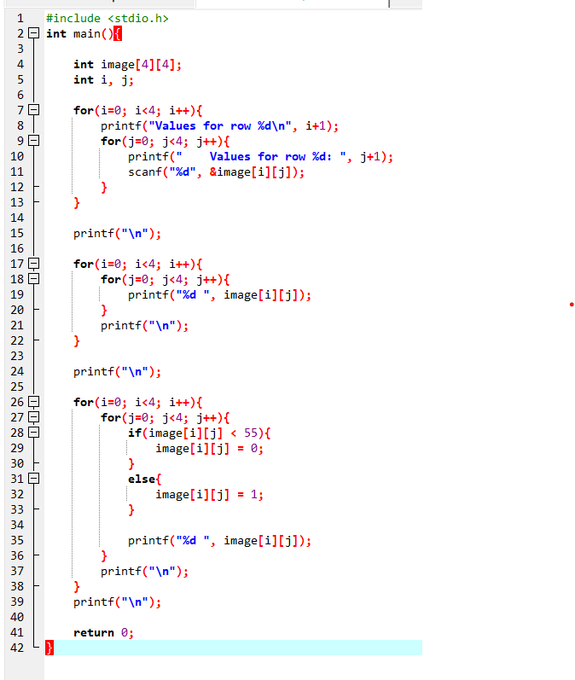

Part b

2023- session1

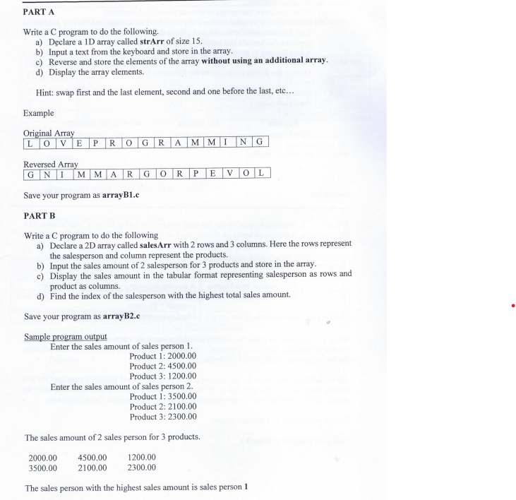

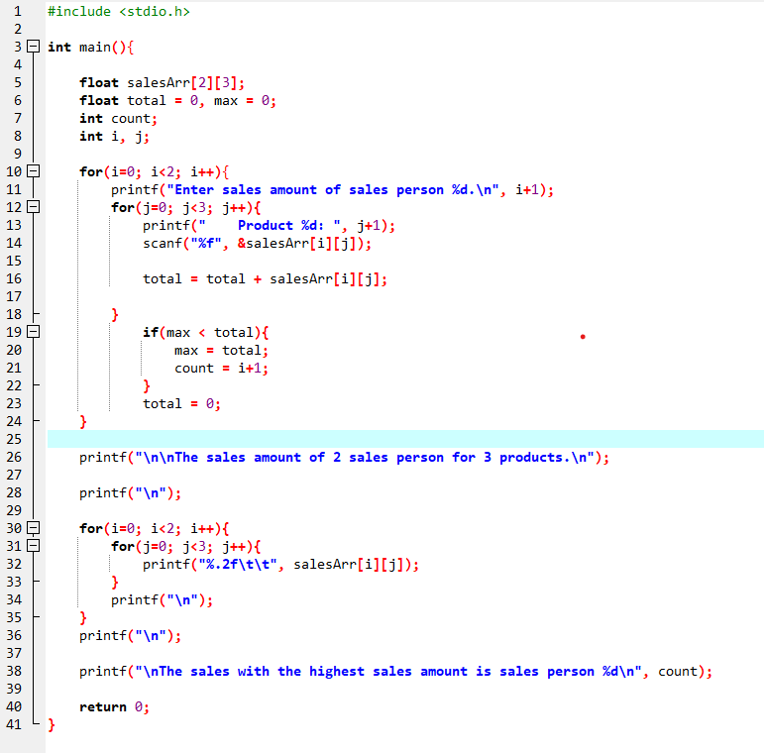

Part b

Part a

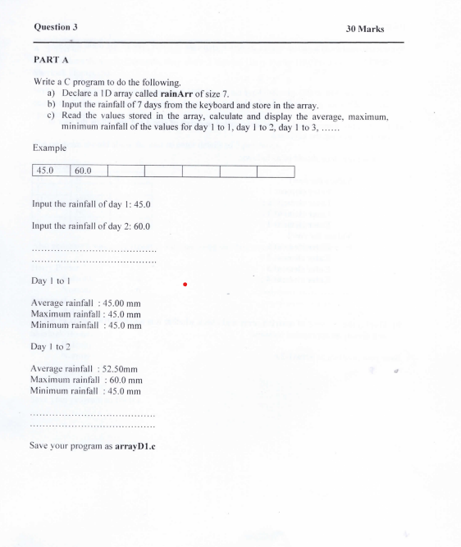2023- session2

Part a

Part b

Model paper Question

